CHATBOT DEPLOYMENT WITH IBM CLOUD WATSON ASSISANT

AI&ADS

Documentation

ABSTRACT;

— For using software applications, user interfaces that can be used includes command line, graphical user interface (GUI), menu driven, form-based, natural language, etc. The mainstream user interfaces include GUI and web-based, but occasionally the need for an alternative user interface arises. A chatbot based conversational user interface fits into this space. The chatbot is a class of bots that have existed in the chat platforms. The user can interact with them via graphical interfaces or widgets, and the trend is in this direction. They generally provide a stateful service i.e. the application saves data of each session. On a college’s website, one often doesn’t know where to search for some kind of information. It becomes difficult to extract information for a person who is not a student or employee there. The solution to these comes up with a college inquiry chat bot, a fast, standard and informative widget to enhance college website’s user experience and provide effective information to the user. Chat bots are an intelligent system being developed using artificial intelligence (AI) and natural language processing (NLP) algorithms. It has an effective user interface and answers the queries related to examination cell, admission, academics, users’ attendance and grade point average, placement cell and other miscellaneous activities. Keywords:- Artificial intelligence, chat bot, knowledge base, lemmatization, natural language processing, semantic sentence similarity, wordnet. I. INTRODUCTION Nowadays, we see the chat bots everywhere Chat bots are the source of answers to the users questions in any particular domain where it is operating. ) domain where it is operating. The most popular example today is the Amazon’s Alexa. Chat bots are at almost every place, one can see it at every second website they visit. A bot is helpful in answering queries related to information which might be unreachable at that website easily. Most of the websites avail users with chat bots to aid them to go through what the websites facilitate. They are turning out to be our virtual assistants in everyday lives. A. Basics of chat bot A chatbot is an artificially intelligent creature which can converse with humans. This could be text-based, or a spoken conversation (in case of voice-based queries). Chat bots are basically used for information acquisition. It can run on the local PCs and mobile phones, though most of the time it is accessed through the internet. It can be compelling, captivating and spell-bounding. It is a conversational agent which interacts with users in a certain domain or on a particular topic with input in natural language sentences. Mainly a chatbot works by a user asking some question or initiating a new topic of discussion. Chat bots can be referred as software agents that pretend as human entity. These are the agents with AI embedded and using NLP they can answer to user questions. Predefined knowledge base helps develop a response to the query. B. Chatbot for College The need for college inquiry system arises due to various reasons which include: the slow nature of college website, an outsider would not know where to search for a particular piece of information, difficult for the person outside college’s domain to extract information. The smart solution for all the drawbacks lends to the need of the system.

IOT

DOCUMENTATION

Abstract and Figures

Internet of Things (IoT) is emerging as a significant technology in shaping the future by connecting physical devices or things with internet. It also presents various opportunities for intersection of other technological trends which can allow it to become even more intelligent and efficient. In this paper we focus our attention on the integration of Intelligent Conversational Software Agents or Chatbots with IoT. Literature surveys have looked into various applications, features, underlying technologies and known challenges of IoT. On the other hand, Chatbots are being adopted in greater numbers due to major strides in development of platforms and frameworks. The novelty of this paper lies in the specific integration of Chatbots in the IoT scenario. We analyzed the shortcomings of existing IoT systems and put forward ways to tackle them by incorporating chatbots. A general architecture is proposed for implementing such a system, as well as platforms and frameworks, both commercial and open source, which allow for implementation of such systems. Identification of the newer challenges and possible future directions with this new integration, have also been addressed.

[…](https://www.researchgate.net/figure/Web-of-Things-as-shown-in-6_fig3_310122692)

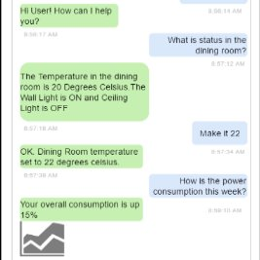

[Sample of a IoT Chatbot-User conversation III. OPPORTUNITIES FOR CHATBOTS IN IOT](https://www.researchgate.net/figure/Sample-of-a-IoT-Chatbot-User-conversation-III-OPPORTUNITIES-FOR-CHATBOTS-IN-IOT_fig1_310122692)

[…](https://www.researchgate.net/figure/Sample-of-a-IoT-Chatbot-User-conversation-III-OPPORTUNITIES-FOR-CHATBOTS-IN-IOT_fig1_310122692)

[[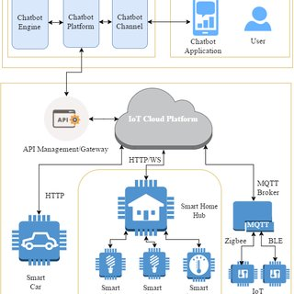](https://www.researchgate.net/figure/Proposed-System-Design-of-IoT-Chatbot-System_fig2_310122692?_tp=eyJjb250ZXh0Ijp7ImZpcnN0UGFnZSI6InB1YmxpY2F0aW9uIiwicGFnZSI6InB1YmxpY2F0aW9uIn19)](https://www.researchgate.net/figure/Proposed-System-Design-of-IoT-Chatbot-System_fig2_310122692?_tp=eyJjb250ZXh0Ijp7ImZpcnN0UGFnZSI6InB1YmxpY2F0aW9uIiwicGFnZSI6InB1YmxpY2F0aW9uIn19" \o "Fig. 3. Proposed System Design of IoT-Chatbot System  )

# bot.py

2

3from chatterbot import ChatBot

4from chatterbot.trainers import ListTrainer

5

6chatbot = ChatBot("Chatpot")

7

8trainer = ListTrainer(chatbot)

9trainer.train([

10 "Hi",

11 "Welcome, friend 🤗",

12])

13trainer.train([

14 "Are you a plant?",

15 "No, I'm the pot below the plant!",

16])

17

18exit_conditions = (":q", "quit", "exit")

19while True:

20 query = input("> ")

21 if query in exit_conditions:

22 break

23 else:

24 print(f"🪴 {chatbot.get_response(query)}")